**Detailed dataset information sheet**

|  |  |
| --- | --- |
| **Information Objective** | Roads and Transport Hubs |
| **Data Products** | National Road Network |
| **Information Source / Model Product** | State Departments |
| **Product Completion Progress** | Procurement stage  Awaiting Northern Territory dataset |
| **Dataset / Metadata Document** | Raw data is stored under individual State/Territory folders |
| **Dataset Use** | Surveillance Strategy and Design, Pathway risk analysis |

**Background**

A national line feature spatial dataset layer identifying road centreline features is being developed from publicly downloadable or sourced with assistance from state level spatial departments.

The uses of this dataset will be broader than those initially envisaged within the Plant Health Policy unit.

The individual state level datasets have a varying range of attribute field information and this will need to be harmonised in future work on this dataset.

Currently all states have contributed their road centreline datasets in an ESRI shapefile format. The only dataset that is yet to be sourced from the NT is in process of being procured.

**Initial Dataset Procurement Process**

The datasets has been imported into ArcMap and the progress of processing each dataset is detailed in Table 1.

A national overview of the current state level datasets in ArcMap view is shown in Figure 1.

Figure 1. ArcMap overview of state level road centreline datasets

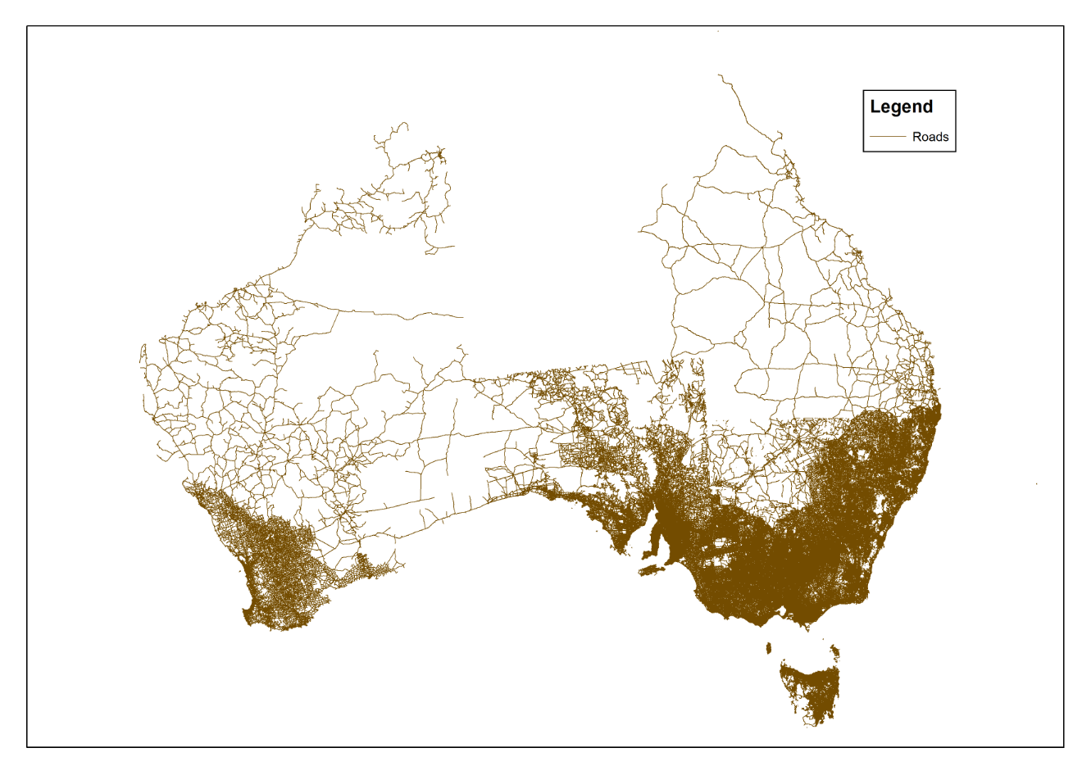

**Limitations**

* None considered at this stage of the procurement

**Quality Check**

* Nil conducted at this stage of the procurement
* Road contiguity along state borders will need to assessed and fixed if erroneous, for example the South Australia and Queensland borders

Table 1. Summary of the datasets and their completion status to date

|  |  |  |  |  |
| --- | --- | --- | --- | --- |
|  | **Dataset procured** | **Dataset reprojected to national grid** | **Dataset Quality checked for contiguity at state borders** | **Dataset Processing completed** |
| **Australia** | **No** | **No** | **No** | **No** |
| Queensland | Yes | No | No | No |
| Victoria | Yes | No | No | No |
| New South Wales | Yes | No | No | No |
| South Australia | Yes | No | No | No |
| Western Australia | Yes | No | No | No |
| Tasmania | Yes | No | No | No |
| Northern territory | No | No | No | No |
| Australian Capital Territory | Yes | No | No | No |

Discussion and Future Work

Once the Northern Territory dataset is received the individual datasets will need to be projected to a uniform national grid and datum.

This will be followed up by a quality check of the road line contiguity along state borders and harmonisation of the attribute data fields to ensure naming conventions and descriptions are consistent.

There also appears to be some overlap across some states for the same road, for example along the Victoria and New South Wales borders. This will required further investigation.

Finally the datasets will then need to be merged into a national layer.

Project Resources Estimates and Uses

An estimate of the timeframes and data procurement requirements required to complete this dataset is summarised in Table 2.

The end result will be a dataset product which is of an Authoritative quality and can be referenced as a point of truth data source for input into projects such as surveillance strategy and design.

This dataset will provide accurate and useful information such as:

* Road Type
* Ownership and Contact information
* Length in kilometres
* Proximity to features in other transport hub datasets such as freight facilities and container, car and pallet storage yards.

And will assist in:

* Mapping requirements for national/state emergency response programs that are deployed when pest incursions occur
* Providing a feed-in data layer alongside the other transport hub datasets for determining distribution pathways and the risk levels of these pathways

Table 2. Comparison of process methods and output dataset quality expectations

|  |  |  |  |  |
| --- | --- | --- | --- | --- |
| **Process** | **Requires Industry Assistance** | **Requires State Government Assistance** | **Estimated time to complete acquisition and processing** | **Expected Dataset Quality Level** |
| State Datasets | No | Yes | ~ 1 week estimate for acquisition of NT dataset | Authoritative |
| National Dataset | No | No | ~4-8 weeks depending on contiguity and alignment errors | Authoritative |